Business Plan Checker
Description:
It is designed to assist entrepreneurs, investors, and students by automatically reviewing startup pitch decks and identifying key business insights. After a user uploads a PDF file, the system uses Generative AI to extract and summarize information based on the user’s query.

Features:
- Pdf upload: User can upload the pdf of startup pitch deck to be analysed.
- Query Input: After the pdf being uploaded user can ask specific question regarding there startup.
- Summarized Output: As per the input given by the user it will give the suitable output according to the pdf is provided by analysing the pdf.
- Document Understanding: The model uses techniques like text extraction and RAG (Retrieval Augmented Generation) to understand the PDF content.

Technologies Used:
- Python: A popular, high-level, and versatile programming language known for its simple, readable syntax, making it easy for beginners to learn and use
- Streamlit: It is an open-source Python library for building interactive web apps using only Python. It's ideal for creating dashboards, data-driven web apps, reporting tools and interactive user interfaces without needing HTML, CSS or JavaScript.
To install Streamlit= pip install streamlit and to run streamlit run sample.py
- PyPDF2 : It is python library that helps in working and dealing with PDF files. It allows us to read, manipulate, and extract information from PDFs without the need for complex software.
- Google-genai:It is a library designed to enable developers to integrate Google's generative AI models in python applications such as for answering queries using extracted data.

- RAG (Retrieval Augmented Generation): An AI technique that combines a large language model (LLM) with an external knowledge base to improve the accuracy and relevance of its responses.

Workflow:
- User uploads PDF.: User can upload only pdf with a limit because the larger the file is, it will take more time to process.Only pdf is allowed and will show error if not uploaded and not pdf type.

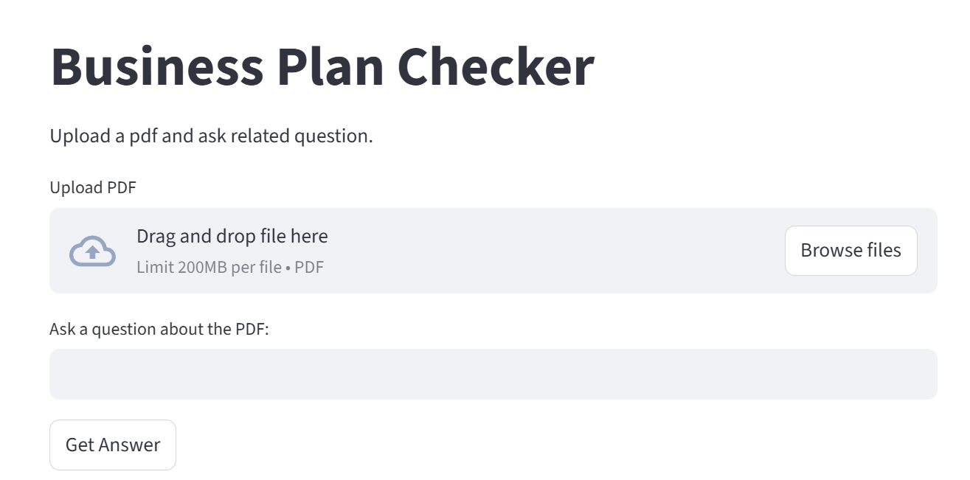

After uploading:

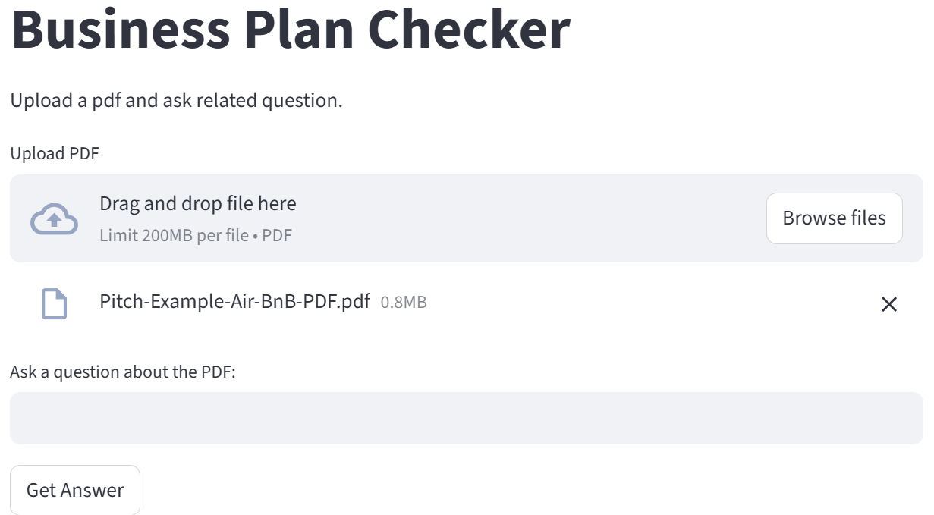

- Text is extraction: When a user uploads a PDF, the computer cannot directly understand the content. So, we first need to read the PDF and convert it into plain text. This text is then sent to the Generative AI model for analysis and feedback.
- Enters a query: After the file is been processed and text is been extracted, the user enters a any question to ai model.
When the user enters the question, the AI start reading both question as well as pdf content and generate an answer based on the business plan.

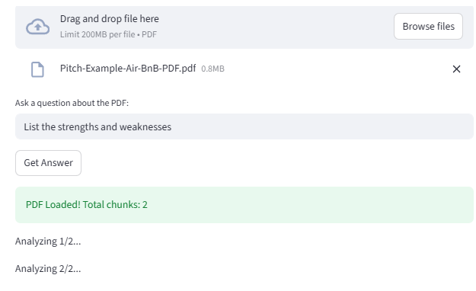

- The system retrieves the relevant section of the document. It compares the question with all the extracted text from the pdf and select the most revent portion of the document instead of using the whole pdf, then passed to the AI model for summarization.
- A large language model (LLM) generates a summarized answer because using its trained knowledge, it analyses the imported points from the document section. The response is returned to the user in as easy to understand format.
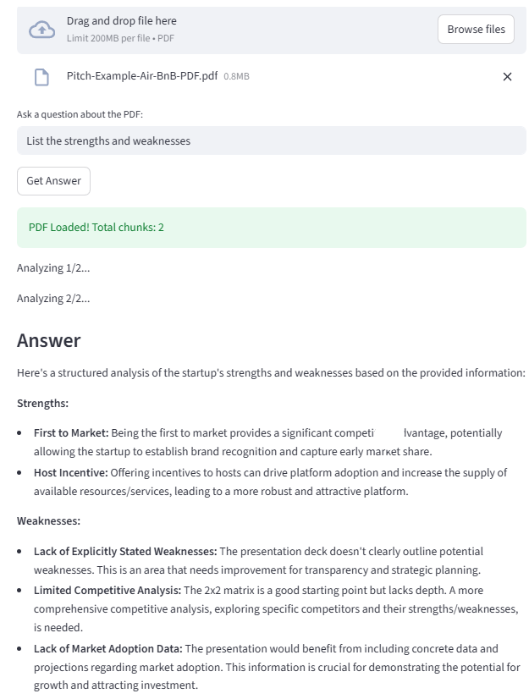

SnapShort:
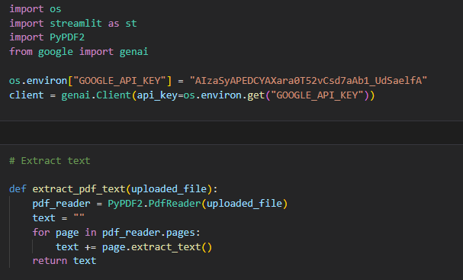
First imports all the necessary libraries and the google api key

We need to extract the text from the pdf which will be uploaded.

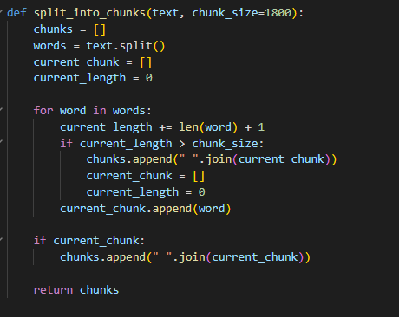
Here the pdf is split into chunks for easy to under by the model to generate the answer.

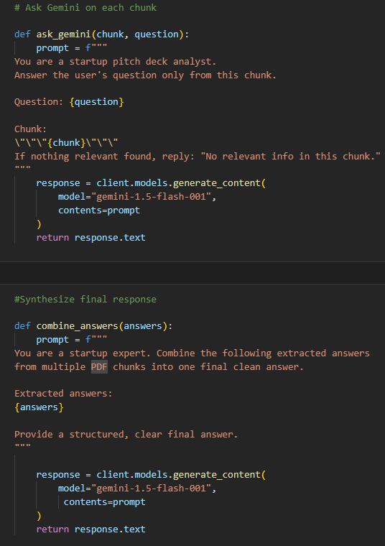
The question given by the user in converting into the chunks for the finding the response.

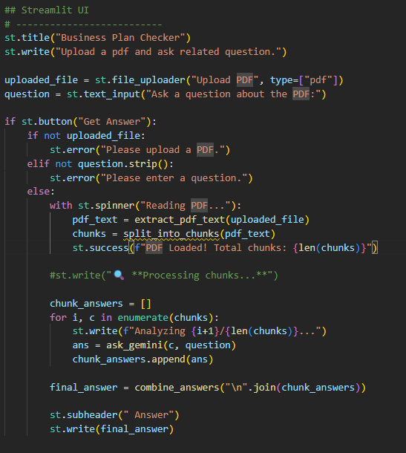
This is the front end by using the steamlit.
We are also checking where it is a pdf or not.
The question ask by the user is relevant in the given pdf.
And give the answer accordingly.

Steamlit doesn’t support the. ipynb file we run the code we have to convert the code into the .py file and by using the terminal we can execute our project.
After executing it give 2 different link to run the project
Local URL: http://localhost:8501
Network URL: http://192.168.0.143:8501

Conclusion:
From this project it shows how Generative AI by using LLM, can help user with long pdf document in an intelligent way. Instead of reading pdf manually, this will help them to analyse is very less time by extracting text, understanding the user’s question, retrieving only the relevant part of the pdf and given a clear summarized answer using LLM.
It improves productivity and support real-world applications such as business planning, education and research.

